THE TOOTER
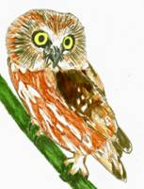
ALLEGHENY HIGHLANDS BIRD CLUB
VOLUME 5, NUMBER 5
Lisa Chapman, Editor
From the President’s Desk: The April meeting of the club was held at the DCNR Bureau of Forestry office in Emporium. The evening program was a program on warbler ID presented by Dave Gelnett. The program was very informative, with video of warbler species, their songs and calls and habitat types and range maps where they occur. After the program, a discussion and question and answer period was held. Under old business, we finally have a pole for an osprey nesting platform, provided by courtesy of Shawn Carlson. The original plan to place it at Sinnemahoning State Park is still in place. This will be dependent on the water level being drawn down at the lake for maintenance work. There are alternative sites available if the Sinnemahoning site isn't feasible in the near future. The recently held fishing derby at Salt Run was well attended, with around 300 people attending. The club had a display with the newly acquired display board set up at this event. The display content was geared towards a beginner/novice birder, sharing information about the club and a bird ID game for young birders. There is also a new birding and nature trail established at Sinnemahoning State Park according to park naturalist Kim Lott and club member Mark Johnson. The signs for the Shawmut Trail system are going to be erected in the near future, according to Secretary Jody Groshek by a volunteer group. There will be bird walks on May 2nd and May 16th, at both Sinnemahoning and Kettle Creek State Parks. Another bird walk is scheduled for Saturday, May 23rd at the Shawmut Trail. Meeting place will be behind the 911 Center, start time will be announced at a later date. The field trip for Geneva Swamp is Sunday, May 17^{th.}. Meeting place and time is going to be at 7am at the Geneva Bridge. Contact person for this field trip is Randy Flament. Members Mark Johnson and Steve Van Eerden mentioned that an 18 passenger type van is available for transporting members during the PMAC on May 9th. A volunteer driver is needed however. That issue shouldn't be a problem because this vehicle doesn't require a CDL license to drive. Member Don Bickford has a candidate to attend the Brook Trout category of the Wildlife Leadership Academy. Her name is Cassie Fry and she is 9 years old. A motion was drafted and approved for the club to donate $250 towards the $500 tuition cost of the program, so Cassie can attend. In return, Cassie will be invited to do a program for the club on her experience at this event on a future date .The nominating committee for the upcoming election of new club officers consists of Laura Carlson, Randy Flament, and Mark Johnson. The results will be presented at the May meeting. The May meeting will be held at the 911 Center at 6:30pm on Wednesday, the 27th.The evening program will be on whitetail deer presented by member John Dzemyan. Hope to see you there.

Last Tooter for the Summer! I’ll resume mass mailing any announcement for field trips or activities as they come up, otherwise look for the next Tooter in September.

Next Meeting: May 27th, 6:30pm at the 911 Center in Smethport. John Dzemyan will present the program on Wildlife Habitat and Deer Impacts On Plants, Birds, and Mammals.

It seems that some of the winter finches and others have stayed in the area late this year. I had been seeing several Pine Siskins at my feeder up until May 9th when I was anxious to add them to my PA Migratory Count. The Dzemyans have had their male Evening Grosbeaks up to the 27th of April and the females until at least May 4. John was also making news by rescuing a tired Horned Grebe that landed in a water puddle along a road. After capturing it by tossing an old shirt over it, he relocated it to a pond.
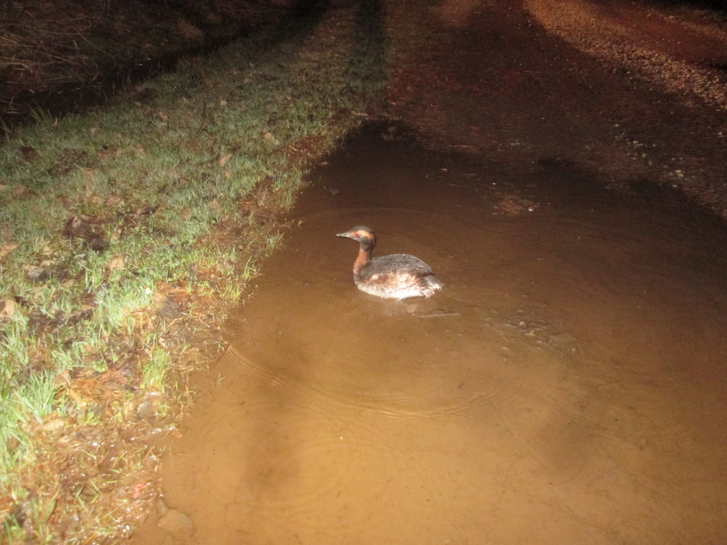
I hope everyone has had a chance to get out on some of the field trips that have taken place so far. Sinnemahoning State Park has had bird walks on May 2 and 16. The Geneva Marsh float/birding trip was May 17th. On May 23rd another bird walk along the Shawmut Trail in Smethport, 8:30am. Many opportunities to get out and get those spring migrants.
And while you’re out there looking, see if you can add something new to our list. We stand at 167 species as of May 12th . Can we get 200 for the year? It will get tough now as the more common ones are logged, the migration wanes, etc. but there is plenty of possibilities?
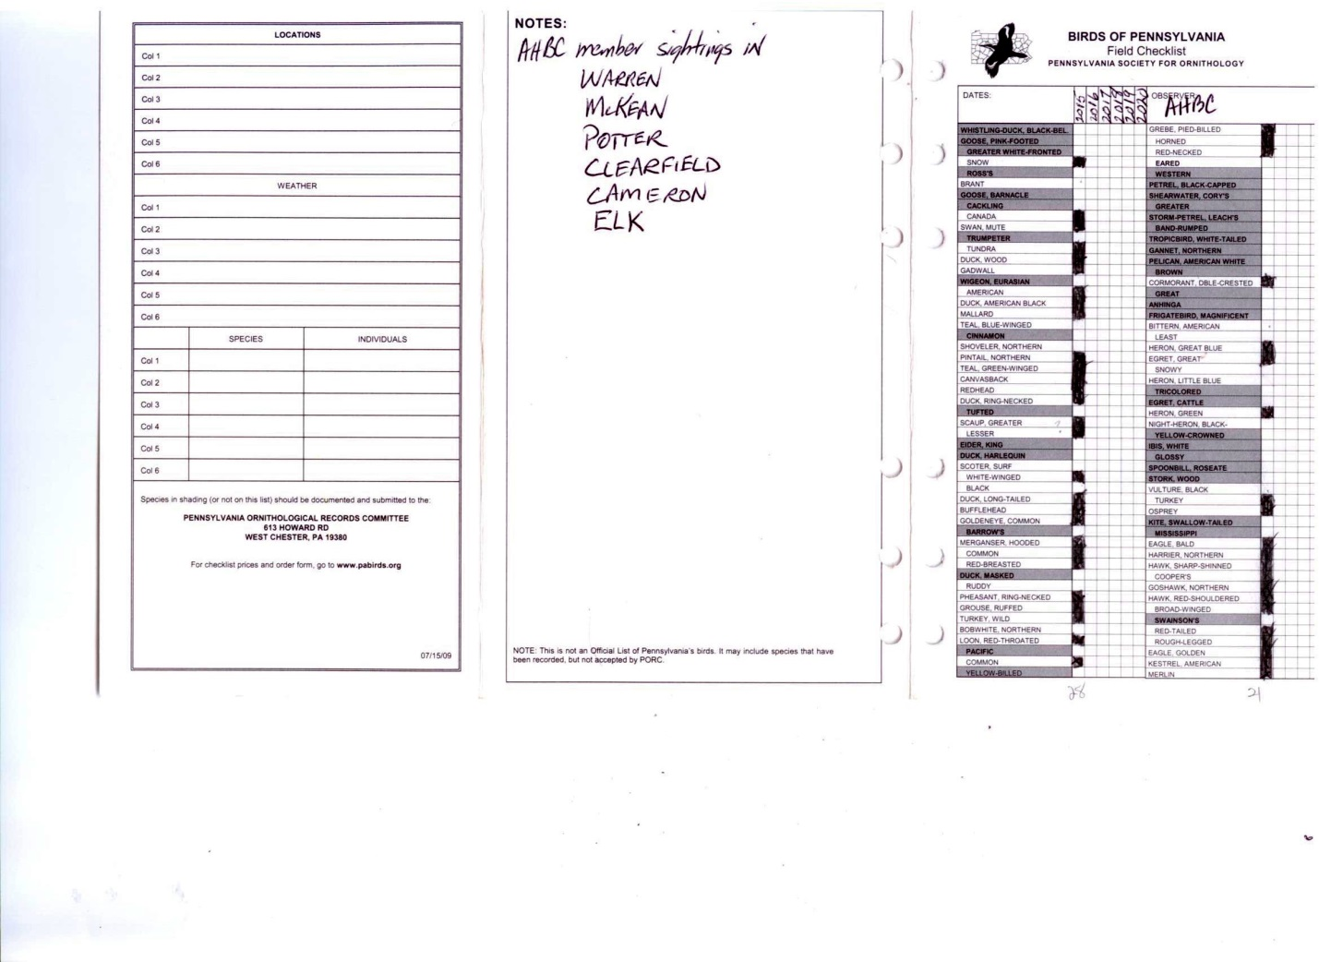
Addendum: After getting John Fedak’s sightings for the year we now have 188!
PAMC 2015
Several club members organized themselves into teams for this event. The Cameron County team employed a roving bus to transport members 135 miles as well as walking 4. The total numbers of species was impressive at 106 and with unflagging persistence racked up 18 hours in the field. Quoting Mark Johnson, “It was another great day with many exciting moments. The dawn hour was magic. Four or five hours of hot afternoon sun though, the birds seemed non-existent. Only Randy’s ears carried us through.” 18 warbler species and 9 sparrow species! Well done team. The McKean County team, (minus John Fedak’s expertise) totaled 51 species after 11 hours of work and covering 45 miles, but had the satisfying privilege of seeing 2 newborn Bald Eagles in nest.
Happy summer birding everyone.

