THE TOOTER

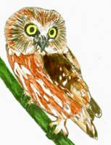
ALLEGHENY HIGHLANDS BIRD CLUB
VOLUME 5, NUMBER2
LISA CHAPMAN, EDITOR

From the President: Hello all,
The January meeting at the 911 Center was very well attended, with about 25 people in attendance. The support and the plethora of ideas for club functions was very much appreciated. The meeting began with a program on wildlife habitat work by our own Len Groshek. Len had a very well presented power point program on different species of wildlife, with habitat projects that explained how to go about tailoring property to specific wildlife needs. Thank you, Len for a great program. The business portion of the meeting consisted of obtaining a folding display board, for club activities. This endeavor was carried out by Jody Groshek. Thank you Jody! The osprey nesting platform project for Sinnemahoning State Park was discussed. A letter of proposal is needed to submit to the park superintendent, and it was agreed to table this matter until the February meeting. A rough draft of the letter will be available at that time for club members to examine. Secretary Jody Groshek has also had paper print outs for signs which will be erected along the Shawmut Trail system. The sign print outs consisted of bird related photos from club members, and narratives on habitat and bird related studies. Erecting the signs will be a volunteer effort from club members. Vice president Laura Carlson is working on a putting together a record book on kestrel and saw-whet owl nest boxes that were erected at various sites in the club membership area. This will require nest box monitoring and reporting from property owners where these nest boxes are erected. Member and bird bander John Fedak reported he banded at total of 13 saw-whet owls this past fall. This is down significantly from the fall of 2013. John further stated, that any nest boxes for saw-whet owls need to be erected no later than mid- February. With the saw-whet owl boxes, preferably erected close to a body of water. John will also be operating his banding station behind the 911 Center in mid- April, to start banding spring migrants. Kim Lott from Sinnemahoning State Park brought up dates for bird walks at the park, with the dates of 3/21 and 5/2. A birding day would be incorporated into the 5/2 date. Establishment of birding trail(s) at the park was also discussed. Although not bird related, Jody Groshek had available at the meeting, information on Pennsylvania Amphibian and Reptile Survey (PARS). Volunteers are needed for this activity, the requirement is that you be able to properly identify different species of reptiles and amphibians. Findings and locations for any reptiles and amphibians found, can be submitted through the PARS website. Field trip ideas consisted of possible trips to Geneva Swamp, Presque Isle and Middle Creek WMA. More information on these possible trips will be discussed at the February 25th meeting. In closing, it was brought to the club's attention that 10 more kestrel boxes are being constructed as senior projects. This is being done under the guidance of member Don Bickford. Jody Groshek also informed club members that there is a fourth category that has been added to the youth conservation camps. The fourth category is black bears, with the others for ruffed grouse, whitetail deer and brook trout. The next meeting will be at the 911 Center February 25th at 6:30pm.
Next Meeting: February 25th 6:30 pm at the 911 Center in Smethport.
This meeting is a combined work and planning session. Anyone who can come early at to help clean out bluebird boxes on the trail, please do. We will need to reach consensus on the proposed Osprey platform at SSP, as well as other topics. Refreshments will be provided by Steve Van Eerden.
Winter Finches: Immediately after the ice storm last Monday, my feeders hosted and influx of Common Redpolls and a few Pine Siskins. I hope others got a chance to see them. They have come every day for nearly a week and provided the opportunity to add them to the Great Back Yard Bird Count. Niger seed in a tower feeder was successful here. Ron Pittaway from Ontario publishes a finch forecast for the region each winter and this year’s prediction was one of a “mixed bag”. Based on the seed crops, Purple Finches and Common Redpolls were expected to irrupt south due to the scarcity of birch seed.
http://www.jeaniron.ca/2012/winterfinches.htm for more info on Finch facts, Seeds, and Irruptions.
Wilsons Snipe: Mark Johnson passed on this picture of Wilsons Snipe that he took on Valentine’s Day. For 8 out of 11 of the past Emporium Christmas Bird Counts, this bird has been found and here is the documentation!
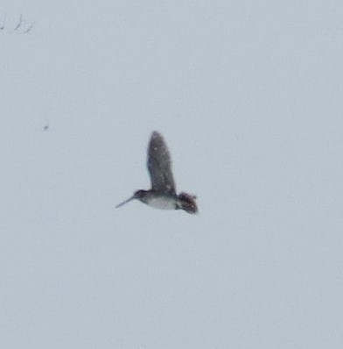

TrailCam Report: Steve VanEerden states there has been a steady stream of visitors to the Cameron County Carrion Pile. Here are a couple of pictures.
