THE TOOTER
ALLEGHENY HIGHLANDS BIRD CLUB

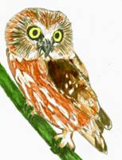
VOLUME 5, NUMBER 4
LISA CHAPMAN, EDITOR

From the President’s Desk:
I just wanted to start out by informing everyone that the bluebird boxes along the Shawmut Trail behind the 911 Center are all cleaned out now and ready for the upcoming nesting season. I arrived about an hour and a half early and finished cleaning out the nest boxes on the opposite side of the creek. The meeting started with a power point program on flycatchers by our very own Lisa Chapman. The program was very well presented, kudos to you, Lisa. The business portion of the meeting started out with the treasurer's report. We currently have a balance of $1338.35 in the club's account. A bill was paid to cover the cost of the club's new display board, leaving the club with the current balance. Under old business, the osprey nesting platform project at Sinnemahoning State Park can take place this spring and summer at the park. The task may be much easier, because the park is doing a drawdown of the lake to perform dredging work. Also, according to secretary Jody Groshek, signs have been ordered for the Shawmut Trail system and banding station. Member Mark Johnson has the cooperation from park staff to establish a birding trail system at the park. Volunteer work on the part of the of club members is needed to help with this endeavor. Under new business, a scholarship to the Audubon Hog Island summer camp for a biology teacher in the club's membership area was further discussed. An announcement letter to be distributed through the school districts was presented by vice president Laura Carlson. At this time the amount of the scholarship the club will assist with, is $500. It was agreed that this amount wouldn't be fixed; that it could be less, depending on the club's financial situation. It was agreed that essays and applications would be reviewed by an executive committee. The scholarship program for a youth conservation organization was tabled until next year due to the deadline being close. April 18th , Saturday ,in Emporium, there will be trout fishing family event at Salt Run. Bird bander Keith McKenrick will be there. To round out a station towards bird related activities, the club will have members present at this function, along with the club's new display board. Member Don Bickford ordered and brought to the meeting bird related educational materials that can be used for future club functions. In addition, Bick also brought several completed kestrel boxes for distribution. The field trip to Geneva Marsh on May 17th is definitely a go. A meeting place for any members planning to go on this field trip will be will be finalized at the April 22nd meeting. The next meeting (April 22nd), will be at the Bureau of Forestry DCNR building in Emporium. The evening program will be announced at a later date. Hope to see everyone there.

NEXT MEETING: Wednesday, April 22nd, 6:30pm in EMPORIUM at the DCNR building on Sizerville Rd. Rt155. David Gelnett, Education Specialist with the Department of State Parks will present a program on warbler identification and business meeting will follow. Kim Lott will provide refreshments.

UPCOMING FIELD TRIP: An exciting trip is being planned to the Geneva or Conneat Marshlands on May 17th. Birding by kayak or canoe out into reeds provides a chance of seeing elusive rails, wrens, sparrows, prothonotary warblers and other species. For those not seaworthy, or preferring to stay on dry land, the swamp edge could also be productive. When plans are finalized, meeting point and time, I will send out a separate post.

PA MIGRATORY BIG DAY is Saturday May 9th. This is traditionally a Big Day Count and once again club members are asked to find sponsors to pledge a certain amount per species or donate a fixed amount. This proved to be a very successful fund raiser in the past and we would like to continue so the funds will be available for future scholarships and other projects.

TIOGA COUNTY BIG WATER: As comfortable and predictable as favorite birding haunts can be, I always get excited about exploring a new place. I happened to be in the Wialliamsport area the morning of April 10th and decided to divert my return home through northern Tioga County to see what waterfowl might be about Lakes Hammond-Tioga and Cowanesque. These lakes are a result of Army Corps of Engineers flood control projects and have miles of shoreline as well as campgrounds, boat launches, etc. The water was very high on Hammond Lake and many of the access roads were closed. Where I could get close a nice compliment of gulls and a tern (?) were present. Mallards, Bufflehead, and a pair of Horned Grebes gave good looks and two Osprey platforms were occupied. Although I didn’t see it, there is also an active Bald Eagle nest. I did not see much of Lake Tioga and Cowanesque still had a thin ice sheet but gulls were there in good numbers too. It is probably a two hour trip for most of us, but easy to find by heading north from Wellsboro on Rt 287. State Game Lands just outside of Wellsboro known as “the Muck” has a wildlife viewing blind on the edge of a swampy area that also may offer surprises. It is known to hold rails. A few pictures:

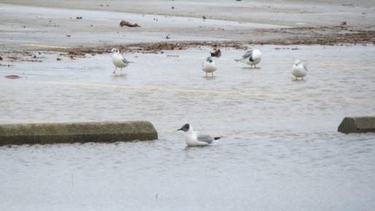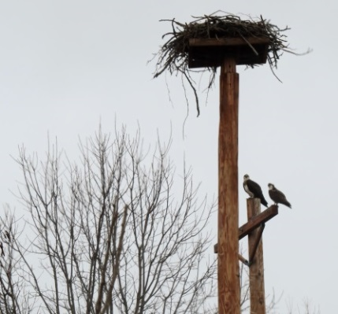

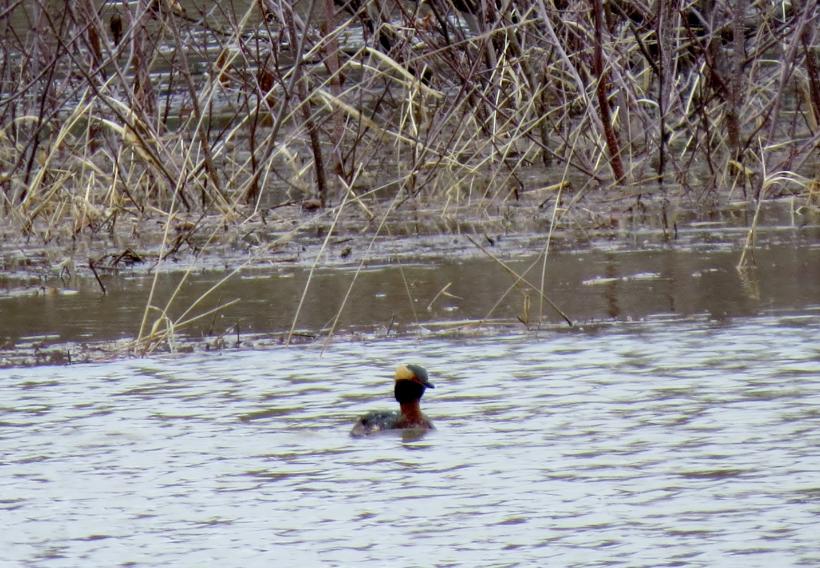

I’m hearing of new birds being seen frequently these days. Laura Carlson spotted Eastern Phoebe, Mark Johnson picked up Northern Shrike and Vesper Sparrow. Chipping sparrows and tree swallows are in abundance in my yard and as of yet, no Eastern Bluebirds. Mark Johnson also reported Yellow=throated warbler at his place on April 13th.

