THE TOOTER
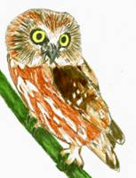
ALLEGHENY HIGHLANDS BIRD CLUB
VOLUME 4, NUMBER 8
Lisa Chapman, Editor
FROM THE PRESIDENT’S DESK: The October meeting began with a power point presentation of the ruffed grouse division "The Drummers" of the Wildlife Leadership Academy, presented by Blaine Groshek. This young man did an excellent job of presenting and explaining the activities of the Wildlife Leadership Academy and the hands on participation in wildlife and plant identification, biology and debating and advocating on sensitive issues that impact the environment. It's young people like Blaine that will pick up the torch to further our cause when our watch is over,not only for birds, but for wildlife and the environment as a whole. The business part of the meeting consisted of discussions on the feasibility of erecting an osprey nesting platform at Sinnemahoning State Park, member Mark Johnson will check with the park manager for approval .Secretary Jody Groshek brought up the subject of the club purchasing a display board for the club, to set up at outdoor related functions in the club's membership area. The cost was presented and motion made to purchase the display board .A shelter type tent for the display board will be purchased at a later date. Also discussed was designing signage to erect at the trail head of the Potato Creek Trail, a committee was formed to address the design and costs of making a sign. We have a total of three hiking trails in the club's membership that can have signs erected and membership brochures displayed in a weatherproof structure. The trails are: Potato Creek, Kinzua and the newly developing West Creek Rails to Trails system near Emporium. Treasurer Bob Martin informed club members of a balance of $1,319.96 in the club's account .A deposit of $140.00 through new memberships and the sale of T-shirts will be made.The 250 membership brochures were approved for printing cost $117.66.Member Steve Van Eerden brought up the subject of invasive plant identification and awareness, while we are out and about on birding or work detail excursions .The sooner an invasive plant species is identified and dealt with,the less cost and effort involved in eliminating it.Member Don Bickford informed club members that 12 additional kestrel boxes and 12 saw-whet owl boxes were constructed through volunteer labor and donated materials.The more boxes the better,especially for the AmericanKestrel,whose populations have declined partially to lack of natural cavities and competition with European starlings.Member Mark Johnson will be at the Bucktail Lookout,also known as "The Top of The World", this Saturday October 25th.If you have some free time,I'm sure Mark would welcome some company.Upcoming Christmas Bird Counts are as follows: Dubois December 20th, Emporium December 21,Benezette December 28th.There will be no clubmeeting in November due to Thanksgiving.The next meeting will be Wednesday December 17th at the 911 Center.Hoping everyone has a safe and enjoyable Thanksgiving.
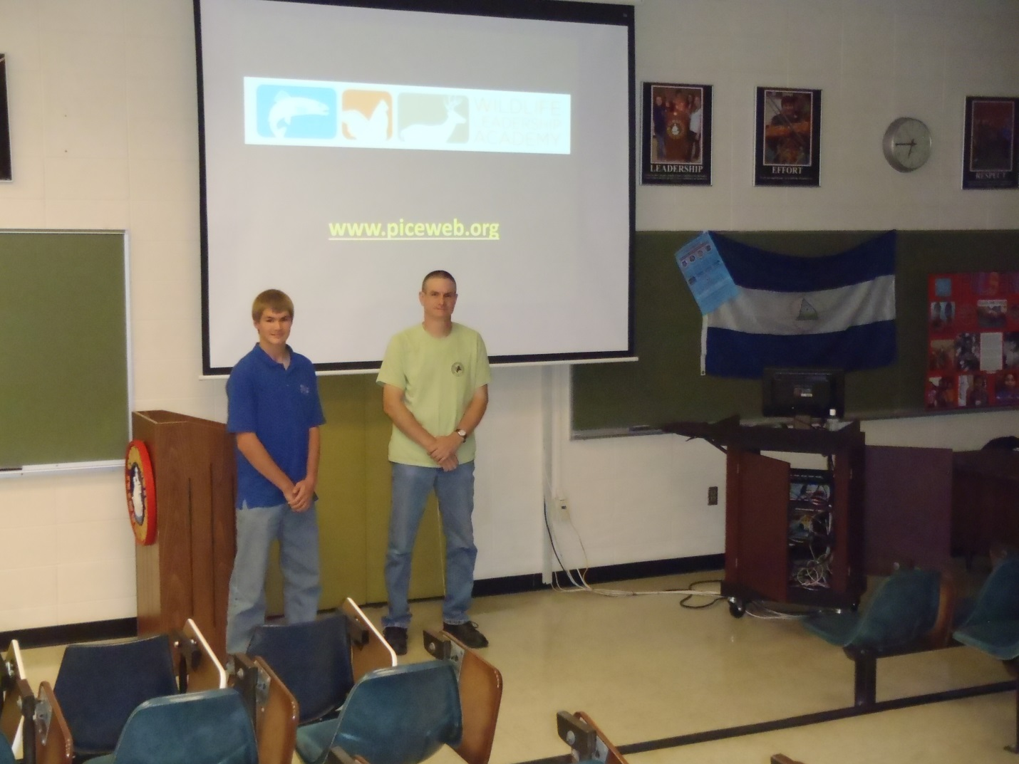

Anyone interested in getting our young people more information about Wildlife Leadership Academy can go to: www.piceweb.org. for 2015 listing of camps.
BUCKTAIL OVERLOOK FIELD TRIP: Three club members met at this site on October 25th for raptor watching. It was warm this year with steady north and northwest winds. Turkey Vultures were in abundance, I stopped counting at twelve. A mature Bald Eagle and a couple of Red-Tailed Hawks came through as well as an unidentified accipiter and Common Raven. What was most interesting was watching the flight paths and styles of these birds as they caught the wind currents which were numerous and ever changing on that vast landscape.
NEXT MEETING: Tim Baird will present a program entitled “A Program for Bird Nerds”. Tim is a retired high school science teacher who has been birding the southern tier of New York State and beyond for the past 40 plus years. He is a past president of the New York State Ornithological Association and current president of the Cattaraugus County Bird Club. Refreshments will be provided by P. Farmer and L. Chapman.
SIGNAGECOMMITTEE charged with developing a plan to get signage up on the Shawmut Trail in Smethport has been busy. We have met jointly with the Potato Creek Trail Association and the McKean County Conservation District to outline the content for three signs addressing Citizen Science, (banding), habitat and nest boxes, and grassland species. Since all three entities will be putting up interpretive signage an effort is also being made to make them look uniform. The AHBC signs will have a QRC icon which when used with the appropriate smart phone app will link the visit to an up to date bird list and/or bird calls. We will compile the bird list at our December meeting.
WINTER RAPTOR SURVEY: Greg Grove’s survey will run from January 10-February 10 this year. Greg can be reached at gwg2@psu.edu if you would like to discuss a new route with him or find someone to pair up with.
SNOWY OWLS seem to be showing up again so keep your eyes open. Some of those with tracking collars including Millcreek (Erie) are moving south from Quebec. More information at www.projectsnowstorm.org.
CHRISTMAS BIRD COUNTS: Hope everyone who wants to has had a chance to sign up for participation in a count. Besides the three Pennsylvania counts listed in Chris’s paragraph, the Cattaraugus County Bird Club has a count on December 14th. I hope to get in all three!
WE HAVE A WEBSITE!!! Thanks to the hard work and talents of Jody Groshek you can see our website at www.ahbirdclub@weebly.com.
PHOTO CREDITS: We have made an effort to make sure photo credits are on the webpage, Facebook, and the signage. Please let us know if we used any of your photos without mention, or if we have planned to use them and you prefer that we do not.

