THE TOOTER
ALLEGHENY HIGHLANDS BIRD CLUB
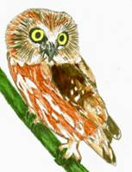
VOLUME 5 NUMBER 1
LISA CHAPMAN, EDITOR

From the President’s Desk: Hello all. The December meeting at the 911 Center started off with a power point presentation by Tim Baird-President of the Cattaraugus Co., NY Bird Club titled "A Program for Bird Nerds" .It was a very well presented program with a quiz that went with each image .I'll admit ,it was very creative and some of the photos and questions were challenging. The business portion of the meeting consisted of some prints and a bird list that were presented by Lisa Chapman. The signs (cost permitting), could have a QR bar code that could be scanned with a smart phone linking the user to the club's new website, which was set up by Jody Groshek. The idea of appointing someone to monitor and collect data on the kestrel boxes set up by club members was discussed. Anyone accepting this task would contact landowners on the properties the boxes are erected on, and ask questions in regards to use and clean out issues. At Sinnemahoning State Park there is a bluebird trail system with about forty nest boxes that need monitored during the nesting season and cleaned out at the end of the season. The park currently does not have enough staff to devote to this project ,and volunteers would be greatly appreciated .Anyone interested in assisting with the park's bluebird trail system ,please contact Kim at the park office .Also at Sinnemahoning State Park, there will be a winter bird walk lead by our own Mark Johnson on January 17th,starting at 10am.There are three area Christmas Bird Counts coming up, Dubois on Dec. 20th, Emporium Dec. 20th and Benezette Dec. 27th.The winter raptor survey will run from Jan. 10th to Feb. 10th 2015.Our own Lisa Chapman will be participating in this survey. Anyone interested in participating in a winter raptor survey close to where they live, contact Greg Grove through PSO. Our next meeting will be Wednesday January 28th at the 911 Center at 6:30pm,our own Len Groshek will be doing a program on habitat .Hope to see you there. Wishing you and your families a Merry Christmas and a Happy New Year

NEXT MEETING: January 28th at 6:30pm 911 Center in Smethport. Member Len Groshek will present a program on habitat. This is a good chance to ask an expert about bird friendly plants to use around home, bird specific habitats, and invasive plant problems. Refreshments will be provided by the Grosheks.
DUES ARE DUE: It is time to renew your membership. Student $5, Individual $10, Family $15 payable to Bob Martin, 125 Elmwood Drive, Emporium, Pa 15834
NOMINATING COMMITTEE: Consistent with our by-laws, the Board of Directors (officers), will appoint a nominating committee consisting of one officer and two club members who will present candidates for officers to be approved at the May meeting. In addition, nominations may be made from the floor at this time. The officer’s position runs for two years and can be repeated for another two year term. Please consider volunteering to help strengthen this fine club by assuming one of these positions. Many sincere thanks to those people who have already done so.
CHRISTMAS BIRD COUNT TALES: They are by now just a memory, but just a few short weeks ago those of us who participated in the various Christmas Bird Counts in the area were beating the bush far and wide to drum up one more species so we could hit a threshold of twenty or thirty species. We will look back and chuckle when reflecting on this in May, but at the time it was the challenge of the day. All self-respecting birders are up for a challenge. I asked anyone who joined a count circle to share their experience for this Tooter.
Chris Grecco: I was assigned to two areas of the Dubois Count Circle. The best bird of the day was American Crow at 63 individuals. 200 birds observed across 22 species sums my day. Unfortunately, no pictures were made. The highlights for me were an American Kestral, 3 Red-Tailed Hawks, 1 Bufflehead, and 7 Black Ducks.
Lisa Chapman:I was lucky enough to get in on three counts this year. December 14th was the 65th St Bonaventure CBC. This was the fourth year I’ve done this count and the second year at that portion south of the Allegheny River and ascending to Rock City Hill. I’ve been excited to get a chance to look at the river, but it didn’t really pay off this year. The highlight was getting four species of woodpecker and some Wild Turkeys. 23 species in all and a total of 511 birds, most abundant being Rock Dove made up my contribution. The following Sunday in Emporium it was brisk but beautiful. Lisa Bainey and I spent the morning cruising feeders which were quite active. We saw 16 Blue Jays at one time at one site, and thought this is going to be the bird of the day. Ms. Baineyhas a sweetstrip she calls her “Honey Hole” which offered many birds including our best bird Common Redpoll, and several White-throated Sparrows.Later I searched the Four Mile road, an area I have come to love because of the remote nature, quaint cabins, large old evergreen stands and my first CBC experience in Emporium. A couple of years ago it was snowing heavily while I was searching for winter finches in the pines. I came upon 5 Ruffed Grouse all fluffed up to twice their normal size and roosting in a small tree. It was a Kodak moment and I had no Kodak. Strains of “Partridge in a Pear Tree” ran through my brain for some time afterward. Since then I have developed a certain affection for this part of the count circle. Our contribution to the Emporium Count was 21 species and 373 total birds. On December 28th I joined the Benezette count and weather wise had a dry but gray day-far better than the drenching I was dreading. Initially, got excited by Northern Harrier and American Kestral looks but as the morning progressed it was hard work scaring up some birds. Toward the end, my partners Phil and Mary Burkhouse and I decided if we conjured up some good Karma we should be able to add a Red-tailed Hawk at the very least. No sooner were the words spoken when eagle eye Mary spotted a pair in tree and right after that a pair of Pileated Woodpeckers! It capped the birding off nicely and despite my “fender-bender” on the way home nicely capped off the 2014 CBC’s.
Laura Carlson: Just because blue birds are fantastic I’ve included a couple of pictures from the Emporium bird count. Kerry Vollmer and I counted the Truman-Howard area. We had a great count and a great walk. The West Creek Trail that is finished and what will be finished is just great!. We had a red tailed hawk and 11 blue birds the second we stepped out of our car. We also had a tree full of cedar wax wings and a tree full of American goldfinches, a corn field with 20 blue jays (with a total of 30) that kept us going. I also included a picture of a sharp shinned hawk that I had taken a couple of weeks before the count in the area that we counted. We ended up with 6 hawks, 2 sharp shinned. We ended our walk with 1 house sparrow and were a little disappointed with that. My car was parked right by West Creek, as we were getting ready to head out (for coffee and a bathroom in Emporium), we noticed birds by the water. They turned out to be 10 tree sparrows getting a drink! I did have a siting of what I think is a pine grosbeak, but me being the aspiring bird nerd that I am, and seeing as how I missed the picture, I’m not sure. Bob Martin said he would see if someone could confirm my siting. Any day in the woods is a good day, and we had a great one!
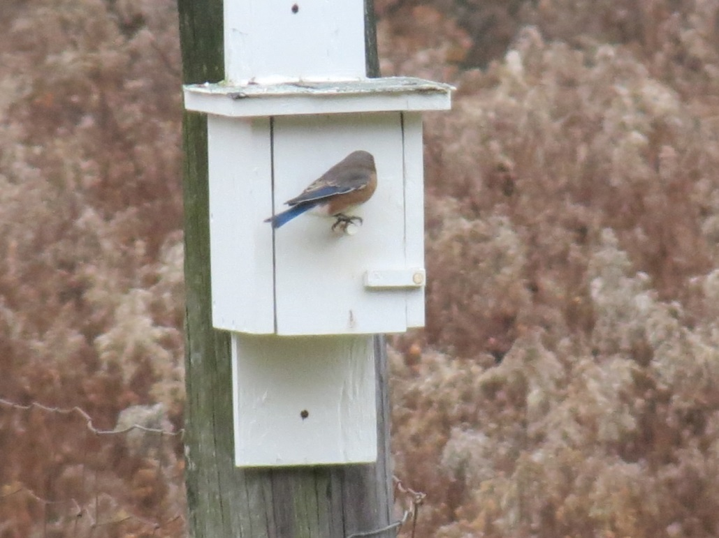

Bick Bickford: Our Emporium Christmas Bird count group usually consists of Mark Johnson, Steve VanEerden, Kirk Bainey and I. Mark has been participating in the Emporium Count since it started over 25 years ago. This is always a fun day and is usually filled with some real exciting moments when a good bird is identified. It turns a bit competitive as we are always trying to break past season records. I believe this year’s count ended at 36 species, which is a little above our seven year average of 34.6. At times it almost seems a little magical. Such as when we pull into a site along the railroad tracks and Mark states “We need a red tail and blue birds on this walk.” We get out of the vehicle and look down the tracks and sure enough a Red tail flies out of a tree and across the tracks. We also get the Blue birds we were looking for. I think what makes the day so exciting is the surprises. Birds you think you can count on cannot be found and the ones you would not expect appear out of nowhere. It is amazing to think that 4 grown men can be seen fist pumping and giving each other high fives because they saw a rock dove or a mourning dove late in the day that can added to the list. I did notice one thing this year that I haven’t in the past. Each time we get back into Steve’s vehicle to go to a new location there were a lot more moans and groans than there used to be. In fact on one occasion I ask Steve to please make sure he hears my door slam before he takes off to assure I have gotten completely in the vehicle. I would like to think it is not a sign of age, but that may be wishful thinking. This year our group added a Saw-whet owl and a Winter Wren, along with a Swamp Sparrow for the first time. Once again this year we got the Snipe that continues to amaze all of us. The eagles eluded us this year but that’s Birding and maybe next year will be better. The best part is spending a day with good friends and sharing your experiences with fellow birders in the evening while having a pot luck dinner and compiling the final numbers for the day. I am proud to be associated with such a great group of people that are so passionate about BIRDS!

GLOBAL BIRDER EXTRAORDINAIRE: If you are interested in those extreme birders who take on Big Years to break records, you might want to follow the blog of Noah Stryker. This 28 year old bird nerd from Oregon is going for 5000 birds across the world. It will be a first for a year of constant every day birding, (no trips home for off days) regardless of the number. The current number stands at 4341. He is sleeping in a tent, traveling very light, (a small carry-on backpack for everything), and foregoing bird guides for the local experts. He has already hit Antartica, the Falklands, and is currently in South America. The strategy is quite interesting and you can follow him at audubon.org/noah.

GREAT BACKYARD BIRD COUNT: February 13-16. Another great chance to count birds for data attempting to define winter populations. You define the backyard and hopefully get your data in ebird. More information on the Cornell website: http://www.birds.cornell.edu/Page.aspx?pid=1478

“Sing on, sweet thrush, upon the leafless bough,
Sing on, sweet bird, I listen to thy strain,
See aged Winter, ‘mid his surly reign,
At thy blythe carol, clears his furrowed brow.”
-Robert Burns, “Sonnetts written on the author’s birthday, on hearing a thrush sing in his morning walk.”

